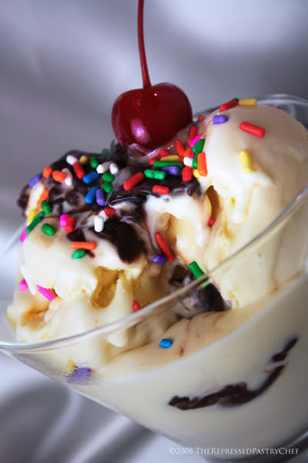  november 2, 2017  2nd grade Bake Sale  ICE CREAM BAR  Welcome Parents of OLA! On Thursday, November 2, 2017, 2nd grade will be hosting our on-campus Bake Sale at recess. This year, we will be having an Ice Cream bar which includes Ice Cream Sundaes and Brownie Sundaes. YUM!! The Ice Cream Sundaes will be priced at $1.50 and the Brownie Sundaes will be $2.00. Your child will get to pick two toppings with the purchase of any Sundae. Any additional toppings will be $ .50 each. Thank you for supporting OLA. GO BRUINS!! | Ice Cream and Brownie Sundaes  ────  Oreo, M&M’s, Sprinkles, Chocolate syrup and more…!!!  ────  Sweet Treats…  ────  Cupcakes, too!  ────  Our Lady of the Assumption  796 West 48th Street  San Bernardino, California, 92407  (909) 881-2416  Recess Bake Sale!

